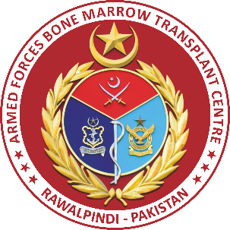
Armed Forces Bone Marrow Transplant Centre, Rawalpindi - Pakistan
3rd International Seminar on Haematology and Stem Cell Transplantation 19-20 November, 2016
Venue: Faruki Auditorium, AFPGMI Rawalpindi
REGISTRATION FORM

Title (Prof./Dr./Mr./Mrs/Miss):

First Name:

Last Name:

Gender:

Your Present Institution:

Work Address:

Email Address:

Phone Number: Mobile Number:

Accompanying guest(s) if any:

Are you going to present in the conference: Yes ☐ No ☐

Preferred medium of presentation: Oral ☐ Poster ☐

Registration Fee: Consultant ☐ Trainee ☐
Rs.1000/- Rs.500/-

Gala Dinner: Consultant ☐ Trainee ☐
Rs.1000/- Rs.500/-

Accompanying Person(s): Rs.500/- each ☐

Registration fee can be paid through bank draft / cross cheque in the name of “Congress BMT Secretariat” along with filled registration form (available on websites www.afbmtc.org and www.psh.org.pk) through postal address “Seminar Secretariat AFBMTC, CMH Medical Complex, Rawalpindi (46000) Pakistan”.

For details or info please contact:
Major Raheel Iftikhar (Secretary) +92-333-5171505
Mr. Humayoon Shafique Satti (Conference Coordinator) +92-333-5397485

