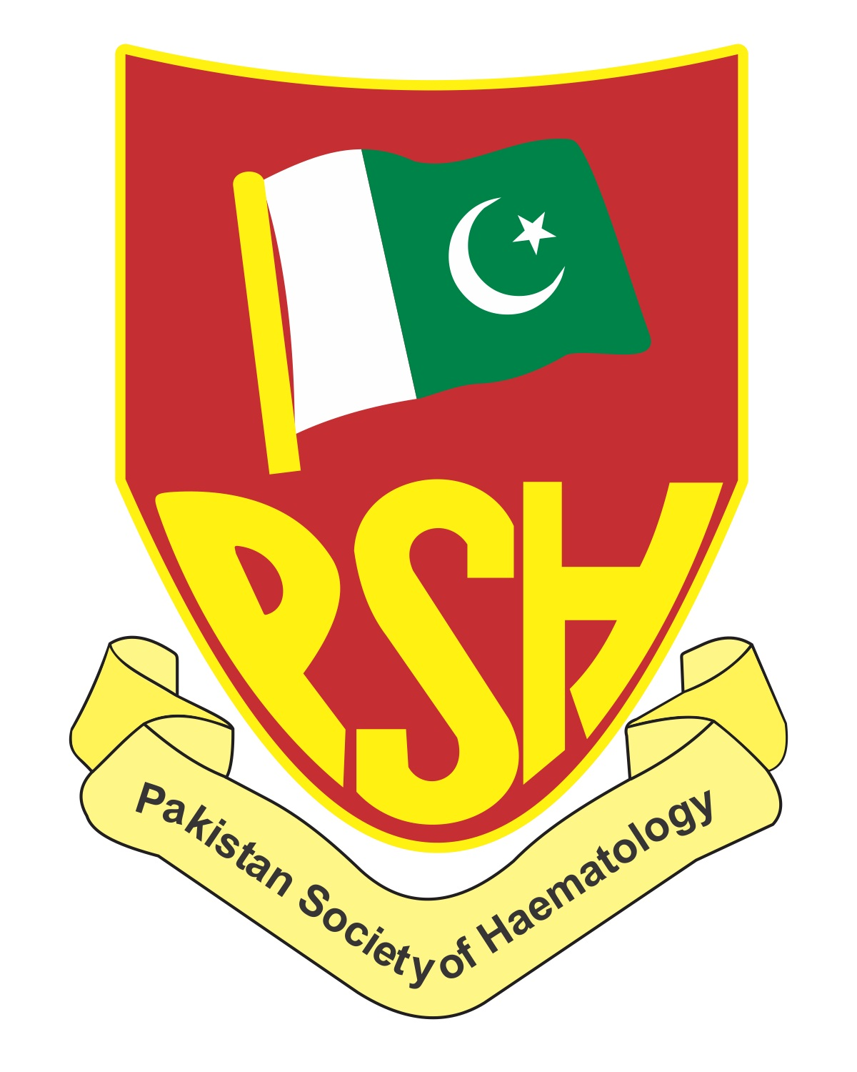
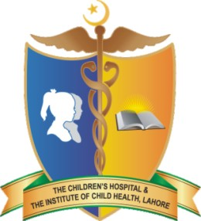
HAEMCON 2017 LAHORE
“Haematology: Challenges in Pakistan”
Pre-Conference Workshop of Medical Lab Technology
Wednesday, February 15th, 2017
The Children’s Hospital and The Institute of Child Health, Lahore

Program |  | Time
Guests to be seated |  | 8:00am to 8:35am
Recitation from Holy Quran |  | 8:35am to 08:40am
Role of Medical Technologists in Health Care System | Dr. Hasan Ejaz  SMT/SRF | 8:40am to 08:50am
Address by the Dean | Prof. Dr. Masood Sadiq | 08:50am to 09:00am
Vote of thanks | Dr. Nazish Saqlain | 09:00am to 09:05am
Tea Break |  | 09:05am to 10:40am
Impact of Clinical Scientist on patients in Haematology | Mr. Abdul Ghaffar  Chartered Scientist  (Guest speaker from UK) | 10:40am to 11:20am
ABC of Anaemia | Dr. Nisar Ahmed  Professor of Haematology | 11:20am to 12:00pm
Flow Cytometry and diagnosis of haematological disorders | Mr. Faheem Shahzad Khan  Senior Lab Manager  UHS | 12:00pm to 12:40pm
Troubleshooting in blood banking techniques | Dr. Nazish Saqlain, AP Haematology  /Mr. Khalid Mehmood, SMT | 12:40pm to 01:20pm
Overview of laboratory testing, differential diagnosis and management of von Willebrand disease | Mr. Abdul Ghaffar  Chartered Scientist  (Guest speaker from UK) | 01:20pm to 02:00pm
Lunch, Prayer |  | 02:00pm

Venue:
Shaukat Raza Khan Auditorium, Diagnostic Block, The Children's Hospital &
The Institute of Child Health, Lahore.

Facilitators:
Dr. Hasan Ejaz 0300-8817047 E-mail: hasanmicro@gmail.com
Ms Humera Javed 0300-4237813 E-mail: humaira0306@gmail.com
Mr. Attiq-ur-Rehman 0333-4985262 E-mail: attiqusa@yahoo.com

Chairman:
Prof. Dr. Nisar Ahmed

